***Chapter 1***

**INTRODUCTION**

**1.1 Motivation**   
**Section** *(Font size 18, Bookman Old Style, Bold)* One line spacing (one enter before section title) before section title. Entire write up should be in Bookman Old Style, Font size 12, with line spacing 1.5 and should be justified.

**1.1.1 User requirement**

**Sub-section** *(Font size 14, Bookman Old Style, Bold)* One line spacing (one enter before section title) before sub section title. Entire write up should be in Bookman Old Style, Font size 12, with line spacing 1.5 and should be justified.

**1.1.1.1 ABCD**

**Sub-sub-section** *(Font size 12, Bookman Old Style, Bold)* One line spacing (one enter before section title) before sub section title. Entire write up should be in Bookman Old Style, Font size 12, with line spacing 1.5 and should be justified.

**General Instructions:**

**Page layout –** left margin – 3.8cm (1.5 Inch),

Top margin – 2.5cm (1 Inch),

Bottom – 2.5cm (1 Inch),

Right margin – 2.5cm (1 Inch).

Spacing between Chapter No. and chapter title should be 2.5cm (approx. 3 line spacing)

Spacing between Chapter title and text should be 2cm (approx. 2.5 line spacing)

**Note: (i) Final Printing should be on a bond paper.**

**(ii) Every Chapter should start on a new page** (preferably from the right hand side page).

**Sample Figure and Table:**

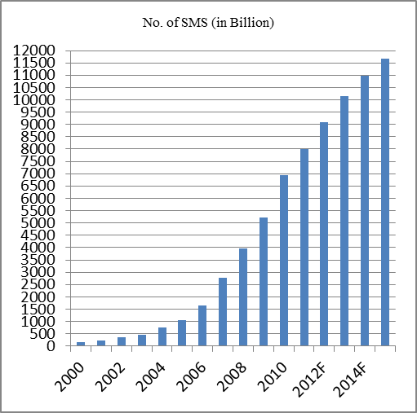

**Figure 1.1:** Growth of SMS – World from 2000 to 2015F (F stands for Forecast) Source: Portio Research Ltd

Table 2.1:Mobile behavior in United States, EU5 (UK, Germany, France, Spain and Italy) and Japan – October, November, December 2010 Percent of total mobile audience (Age 13+)

|  |  |  |  |
| --- | --- | --- | --- |
|  | **US** | **Europe** | **Japan** |
| **Used Messaging** | | | |
| Sent Text Message | 68% | 82.7% | 41.6% |
| Instant Messaging | 17.2% | 14.2% | 3.6% |
| **Accessed Financial Services** | | | |
| Bank Accounts | 11.4% | 8% | 7% |
| Financial news or stock quotes | 10.2% | 8% | 16.5% |

Source: comScoreMobiLens (Feb 2011)